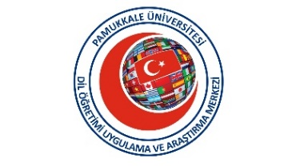

PAMUKKALE UNIVERSITY LANGUAGE TEACHING
APPLICATION AND RESEARCH CENTER
(PADAM)
TURKISH PROFICIENCY EXAM (TYS)
January 15, 2024
- Turkish Proficiency Exam will be held on January 15 Monday, 2024.
Listening, Reading, Grammar and Writing Exam:
Date: Monday, January 15, 2024
Time: 09.30- 11.30
Exam Venue: PADAM
Speaking Exam:
Date : Monday, January 15, 2024
Time: 13.00
Exam Venue: PADAM
- In this exam,
a) Those who registered to Pamukkale University (PAU) for the first time in the 2023-2024 academic year and students who registered in previous years;
b) Those who are not PAU students but want to participate from outside can enter.

- For the exam, an application must be made to PADAM between January 2 and January 12, 2024.

4.

For exam application,
* Photocopy of the passaport ,
* Student Certificate approved by the university (obtained within the last 1 month) (For PAU students)
* A receipt for the exam fee is required.

- To explain the exam fee to the IBAN below, deposit by typing : “Turkish Proficiency Exam (15.01.2024) / Name- Surname / " Your Passport/ID Number ".
Exam Fee: 500 TL
Bank Name: TC HALKBANK
Iban Number for Exam Fee : TR78 0001 2001 4630 0006 0002 39
Account name: Pamukkale University Revolving Fund Directorate (Pamukkale Üniversitesi Döner Sermaye Müdürlüğü)

DOCUMENTS YOU MUST HAVE WITH YOU WHEN ENTERING THE EXAM
- PASSPORT
- STUDENT CERTIFICATE OR STUDENT ID (if available)

6. Those who do not apply for the exam with the required documents and do not comply with the exam rules will definitely not be admitted to the exam.
7. Make sure you have a pencil, sharpener , eraser and spare pencil with you when you come to the exam .
8. You can learn exam results from www.pau.edu.tr/padam
9. If the exam is not taken for any reason, the paid fees are not refunded.

