TASK 1

Student A:

What/favorite/supermarket?

What/usually/buy?

How often/go/supermarket?

When/last/go supermarket?

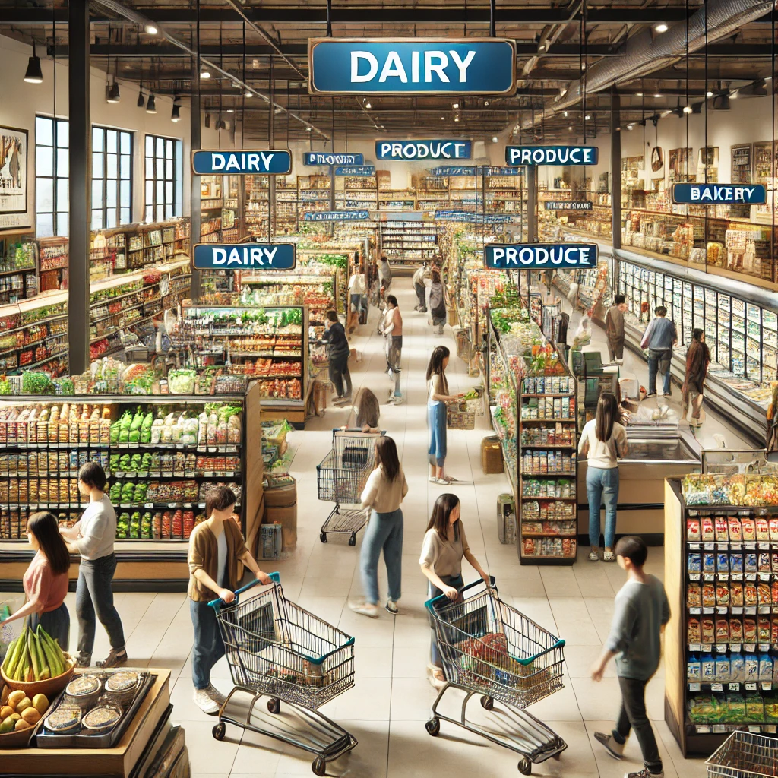
Student B:

What/yours?

How much/spend/weekly?

What time/usually/go?

What/buy/then?

TASK 2
Student A:
like/rainy weather?

What/usually/do/rainy days?

What/activities/winter?

What/least/favorite/weather?


Student B:
What/favorite/weather?
How/stay/dry/rain?

Which/activities/prefer/summer?

What clothes/wear?

TASK 3
Student A:
When/birthday?

What/usually/your birthday?

Who/like/invite/your birthday parties?

What/favorite/birthday memory?


Student B:
What/best birthday gift/ever received?

prefer/big party/a small gathering/your birthday?

What kind/cake/like/your birthday?

How/celebrate your friends' birthdays?

TASK 4
Student A:
like/go/beach?

What/usually/do/beach?

When/last/time/went/beach?

Who/usually/go/beach/with?



Student B:
What/favorite/beach/activity?

prefer/swim/sea/play/sand?

How often/go/beach/vacation?

What/bring/with/beach?

TASK 5
Student A:

What/favorite/way/
communicate?

How often/use/smartphone?

prefer/texting/calling?

When/last/buy/new/device?


Student B:

What/social media/platforms/use?

How/keep/in touch/family?

What/features/look for/new phone?

How much/pay/phone?

TASK 6
Student A:
like/studying/coffee shops?

How often/study/friends?

What/subjects/study/groups?

What/favorite/place/study?

Student B:
What/favorite/drink/coffee shop?

prefer/studying/alone/group?

How/stay/focused/studying/busy place?

When/last time/go/coffee shop?

TASK 7
Student A:
like/go/vacations/friends?

What/favorite/winter/activity?

ever/see/Northern Lights?

What/usually/pack/winter/trip?

Student B:
Where/like/go/vacations?

prefer/summer/winter/vacations?

How/stay/warm/winter/vacations?

What/best/vacation/friends?

TASK 8
Student A:

Who/best friend?

What/like/do/together?

How often/meet/best friend?

When/last time/have/sleepover?



Student B:

What/favorite/activity/best friend?

prefer/staying in/going out/friends?

How/spend/weekends?

What/most fun/thing/did/best friend/recently?

TASK 9
Student A:

What/favorite/clothing/style?

How often/go/shopping/clothes?

prefer/casual/formal/clothes?

When/last time/buy/new/clothes?


Student B:

What kind/clothes/wear/weekends?

How/choose/what/wear/each day?

follow/fashion/trends?

What/favorite/outfit?

TASK 10
Student A:

like/eating/salads?

What/favorite/healthy/food?

How often/eat/fast food?

When/last time/eat/healthy meal?

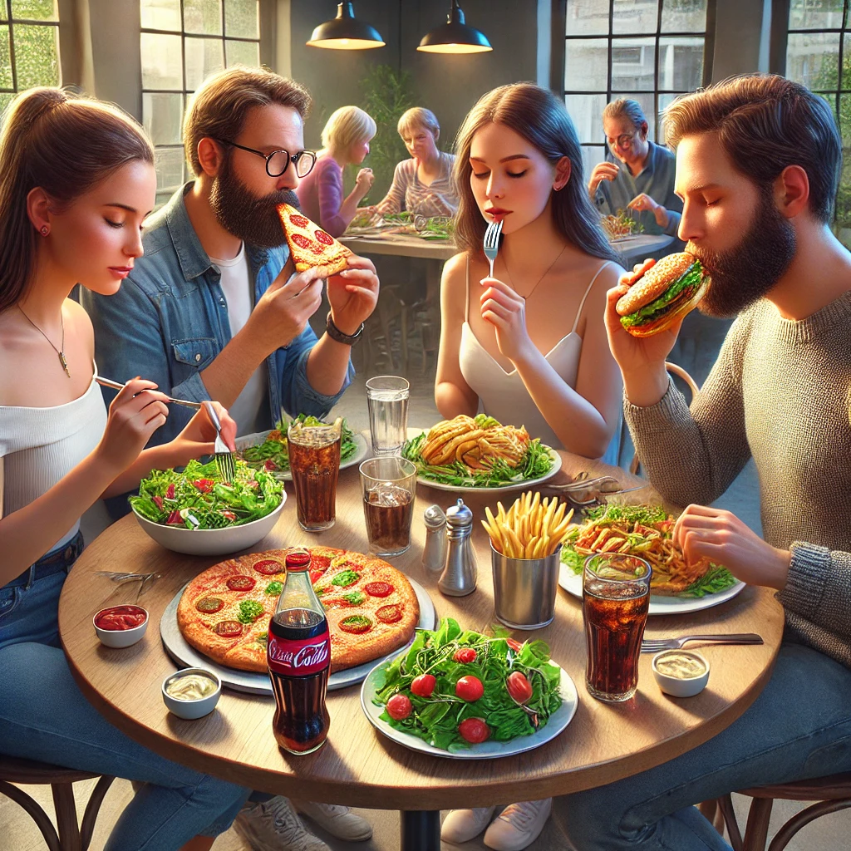

Student B:

What/usually/have/breakfast?

prefer/cooking/home/eating out?

How/stay/healthy?

What/favorite/unhealthy/food?

TASK 11
Student A:
What/do/when/have/cold?
How often/visit/doctor?
What /last/illness/had?
How/usually/treat/headache?

Student B:
What/common/symptoms/flu?
What/do/keep/cold?
How/prevent/getting/sick?
What/worst/illness/ever had?

TASK 12
Student A:
like/going/cinema?
What/favorite/movie?
How often/go/cinema?

When/last time/went/ cinema?



Student B:
What/favorite/genre?

Who/usually/go/cinema with?

What/snacks/like?

What/movie/watch/last time?

TASK 13
Student A:
like/online shopping?

Which website/prefer?

What/advantages?

What/order/last?


Student B:
What/buy?

How often/shop/online?

What/disadvantages?

How much/spend/online/shopping?

TASK 14
Student A:
have/hobbies?

What/do?

How/feel/when/doing?

What kind/music/like?


Student B:
What/hobby?

How much/time/spend?

like/music?

Which/platform/listen/music?

TASK 15
Student A:
like/ shopping?

Which shops/prefer?

prefer/alone/family/friends?
What/buy/last?



Student B:
What/usually/buy?

How often/go/shopping?

What time/usually/go/shopping?

How much/spend/shopping

